Bluetooth Development Notes:

Android Bluetooth source code analysis framework part:

This mainly includes the following contents:

* Source directory
* Class diagram
* Examples of use cases

Bluetooth service initialization

Open the Bluetooth process

Search Bluetooth process

The BT framework code is mainly located in the following directories:

* android/frameworks/base/core/java/android/bluetooth
* android/frameworks/base/services/core/java/com/android/server/BluetoothManagerService.java
* android/packages/apps/Bluetooth

**BluetoothAdapter:**  
  
Represents the local device Bluetooth adapter. The BluetoothAdapter  
  
 * lets you perform fundamental Bluetooth tasks, such as initiate  
 device discovery, query a list of bonded (paired) devices,  
 * instantiate a BluetoothDevice using a known MAC address, and create  
 a BluetoothServerSocket to listen for connection requests from other  
 devices, and start a scan for Bluetooth LE devices.

Path:  
frameworks/base/core/java/android/bluetooth/BluetoothAdapter.java  
public final class BluetoothAdapter {..}

**BluetoothLeScanner**  
This class provides methods to perform scan related operations for Bluetooth LE devices. An Application can scan for a particular type of Bluetooth LE devices using {@link ScanFilter}.   
Path:  
frameworks/base/core/java/android/bluetooth/le/BluetoothLeScanner.java  
public final class BluetoothLeScanner {....}

BluetoothLeAdvertiser:

This class provides a way to perform Bluetooth LE advertise operations, such as starting and

stopping advertising. An advertiser can broadcast up to 31 bytes of advertisement data

represented by {@link AdvertiseData}.

Path:

frameworks/base/core/java/android/bluetooth/le/BluetoothLeAdvertiser.java  
public final class BluetoothLeAdvertiser {....}

**BluetoothProfile:**  
Clients should call {@link BluetoothAdapter#getProfileProxy}, to get the Profile Proxy. Each public profile implements this interface.  
Path:  
frameworks/base/core/java/android/bluetooth/BluetoothProfile.java  
public interface BluetoothProfile {...}  
  
It can be found that there are a series of application layer profile classes, such as BluetoothA2dp, BluetoothA2dpSink, BluetoothGatt, BluetoothHeadset, BluetoothSap, BluetoothPan, etc.  
  
In addition, each specific profile class (such as BluetoothA2dp) depends on the corresponding service implementation (corresponding to A2dpService), and these XXXProfileService will rely on JNI, and finally call to the HAL layer.  
  
path:android/frameworks/base/packages/SettingsLib/src/com/android/settingslib/bluetooth  
  
A2dpProfile.java,DUNProfile.java , HeadsetProfile.java, HidProfile.java, OppProfile.java, PanProfile.java, SapProfile.java,LocalBluetoothProfile.java, LocalBluetoothProfileManager.java, BluetoothEnabler.java,BluetoothSettings.java,CachedBluetoothDevice.java  
  
**Services Path:**  
android/packages/apps/Bluetooth/src/com/android/bluetooth

**3. Sequence diagram**  
3.1 Bluetooth service initialization

SystemServer->SystemServiceManager->BluetoothService->ServiceManager->BluetoothServiceManager

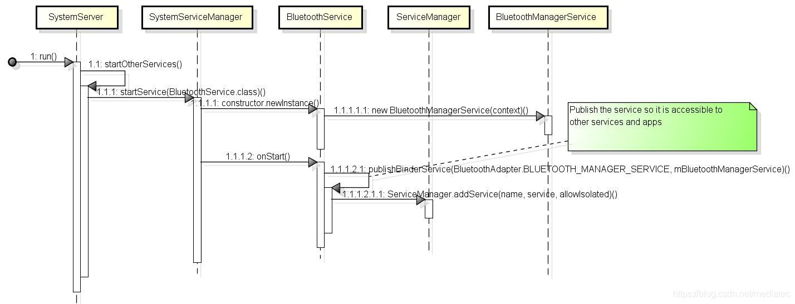

**3.2 Bluetooth open process**

* BluetoothEnabler->LocalBluetoothAdapter->BluetoothAdapter->BluetoothManagerService->IBluetooth.stub->AdapterService

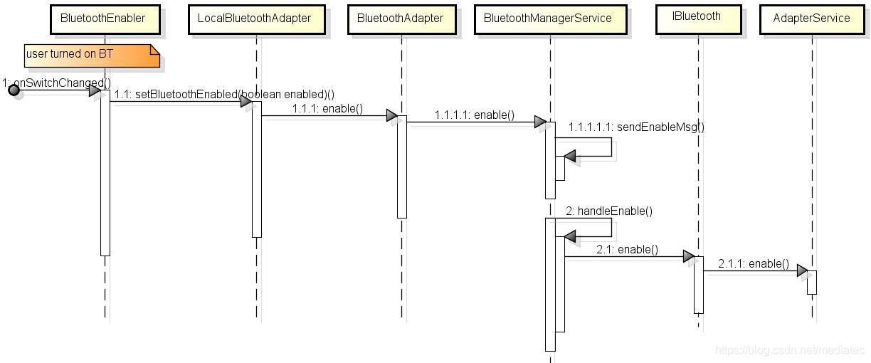

**Each code path:**

android/packages/apps/Settings/src/com/android/settings/bluetooth/BluetoothEnabler.java  
android/frameworks/base/packages/SettingsLib/src/com/android/settingslib/bluetooth/LocalBluetoothAdapter.java  
android/frameworks/base/core/java/android/bluetooth/BluetoothAdapter.java  
android/frameworks/base/services/core/java/com/android/server/BluetoothManagerService.java  
android/frameworks/base/core/java/android/bluetooth/IBluetooth.aidl  
android/packages/apps/Bluetooth/src/com/android/bluetooth/btservice/AdapterService.java

* AdapterService->AdapterState->AdapterService->JNI->bluetooth.h

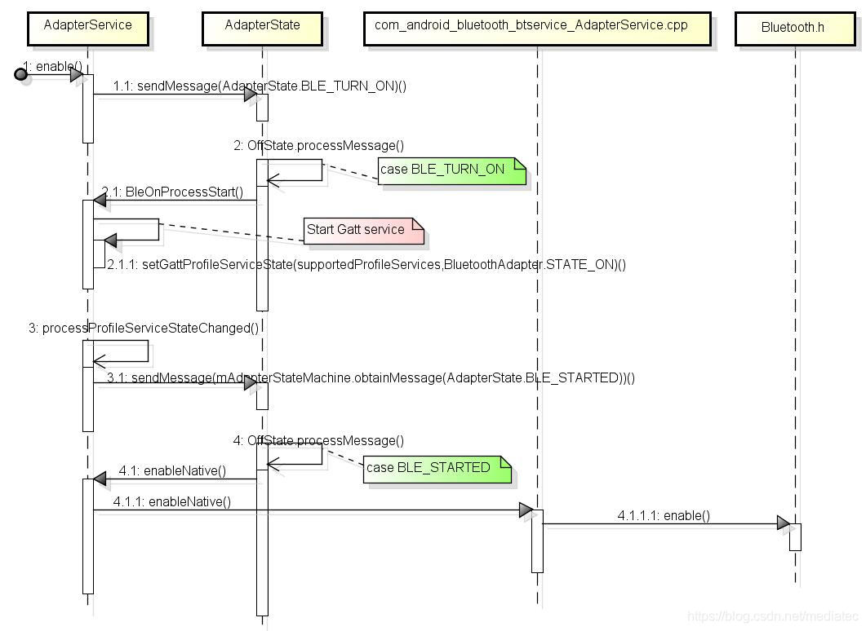

**Each code path and class description:**

android/packages/apps/Bluetooth/src/com/android/bluetooth/btservice/AdapterService.java  
android/packages/apps/Bluetooth/src/com/android/bluetooth/btservice/AdapterState.java  
android/hardware/libhardware/include/hardware/bluetooth.h

**3.3 Bluetooth search process**

* BluetoothSetting->LocalBluetoothAdapter->BluetoothAdapter->IBluetooth.stub->AdapterService

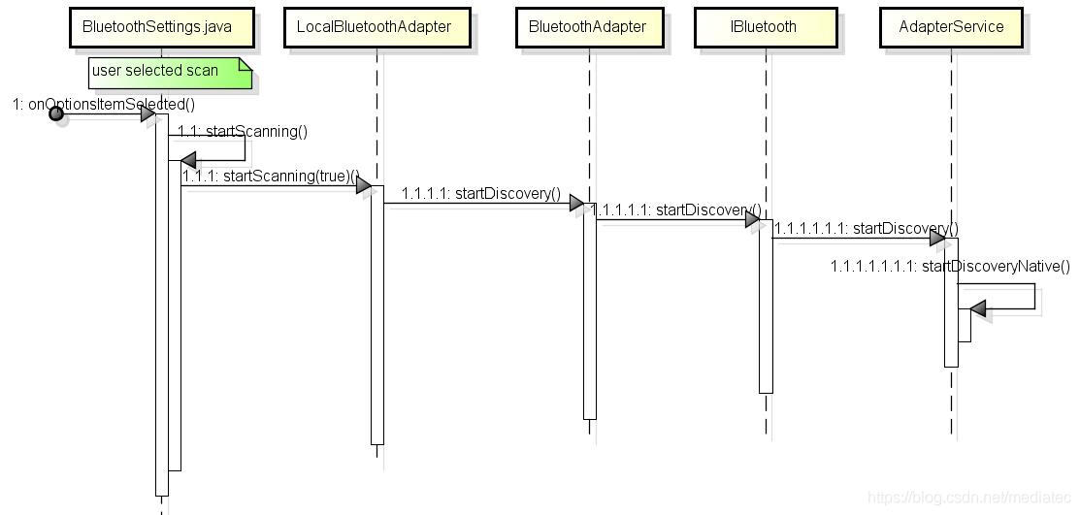

* AdapterService->JNI->bluetooth.h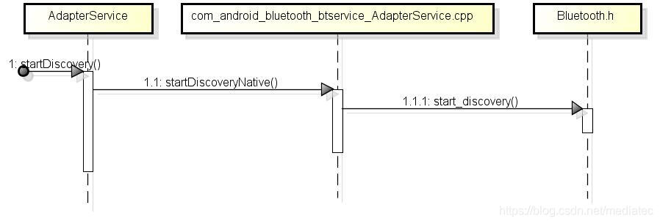

**The Overall Code Structure :**

**1. App/UI part**

packages\apps\Bluetooth\src\com\android\bluetooth\*  
Implementation of Bluetooth FTP, OPP, SAP, BPP, etc. Realization of Bluetooth transmission and pairing.  
packages/apps/Settings/src/com/android/settings/bluetooth  
Bluetooth settings application and settings parameters, Bluetooth status, Bluetooth devices, etc.

**2.Frameworks/base part**  
  
Use android.bluetooth-related APIs to interact with Bluetooth hardware, and internally call the bluetooth process through the Binder IPC mechanism  
  
frameworks/base/core/java/android/bluetooth  
  
Such as BluetoothClass, BluetoothAdapter, BluetoothDevice, etc. Bluetooth applications are implemented through these classes.  
  
frameworks/base/core/java/android/server

**3.Bluetooth JNI interface**

packages/apps/Bluetooth/jni  
frameworks/base/core/jni  
  
It is mainly to provide some low-level API support (C++ implementation) for the Bluetooth JAVA class. Such as headset, socket, etc.

**4.Hardware abstraction layer:**

This layer defines the standard interfaces that the android.bluetooth API and the Bluetooth process need to use. Only by implementing these interfaces can the Bluetooth hardware work properly.  
  
hardware/libhardware/include/hardware.

**5.Bluetooth protocol stack**

This layer implements a universal Bluetooth HAL interface, and can be customized for expansion and configuration.  
system/bt.

**6.Bluetooth's kernel layer**

kernel\drivers\bluetooth\*

kernel\net\bluetooth\*  
 kernel/include/net/bluetooth/*